ACTIVITY-1
POSTMAN

1. What is Postman?
Postman is an API (Application Programming Interface) development tool used to build, test, and modify APIs. It provides a Graphical User Interface (GUI) that allows developers to send HTTP requests to a server and view the responses in a readable format (usually JSON or XML).

2. The Big Four: HTTP Methods
In documentation, these are referred to as CRUD operations (Create, Read, Update, Delete).

GET | Read Data
- Purpose: To retrieve data from a server.
- Safety: It is a "safe" and "idempotent" operation, meaning it should never change the data on the server, no matter how many times you call it.
- Documentation Note: Parameters are usually passed in the Query String (the part of the URL after the ?).
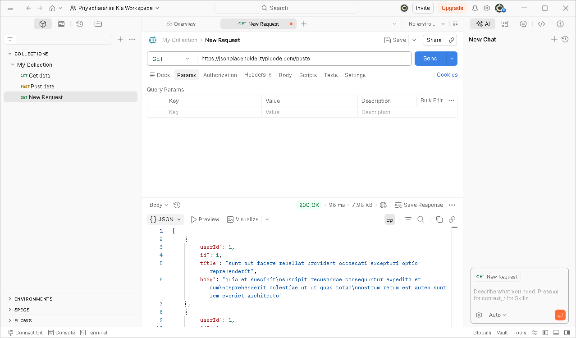

POST | Create Data
- Purpose: To send data to a server to create a new resource.
- Characteristics: It is neither safe nor idempotent. If you click "Send" twice, you might create two identical records.
- Documentation Note: Data is sent in the Request Body.
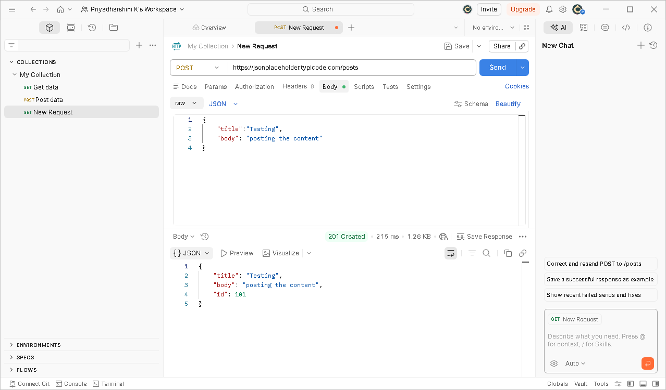

PUT | Update/Replace Data
- Purpose: To update an existing resource or replace it entirely.
- Characteristics: It is idempotent. If you update a user's name to "John" five times, the result remains the same: the name is "John."
- Documentation Note: Requires a specific identifier (like an ID) in the URL.
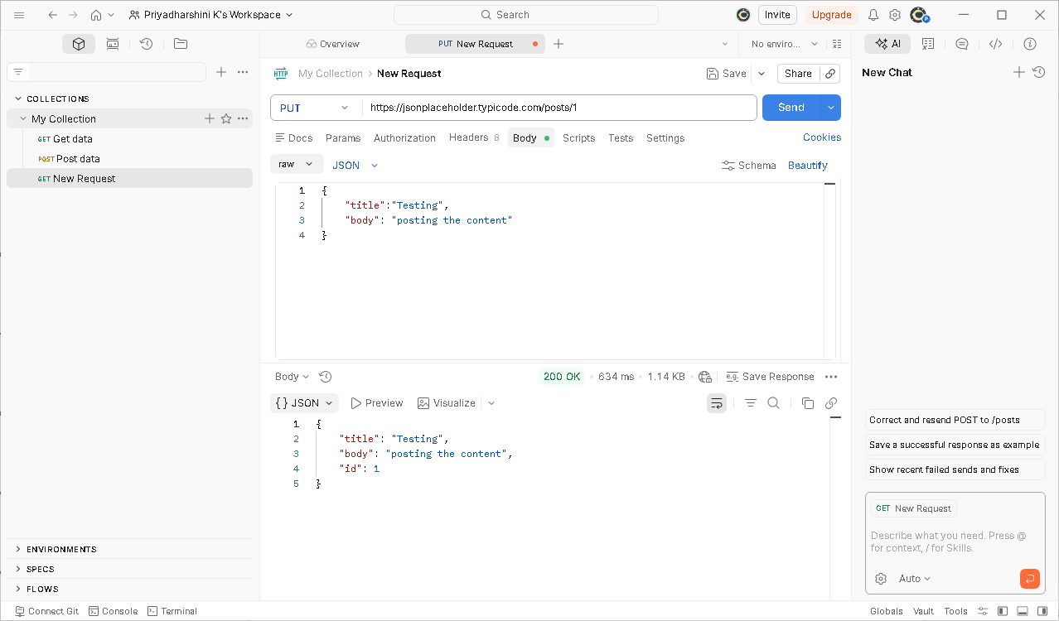

DELETE | Remove Data
- Purpose: To remove a specific resource from the server.
- Characteristics: Once a resource is deleted, subsequent GET requests for that resource should return a 404 Not Found.
- 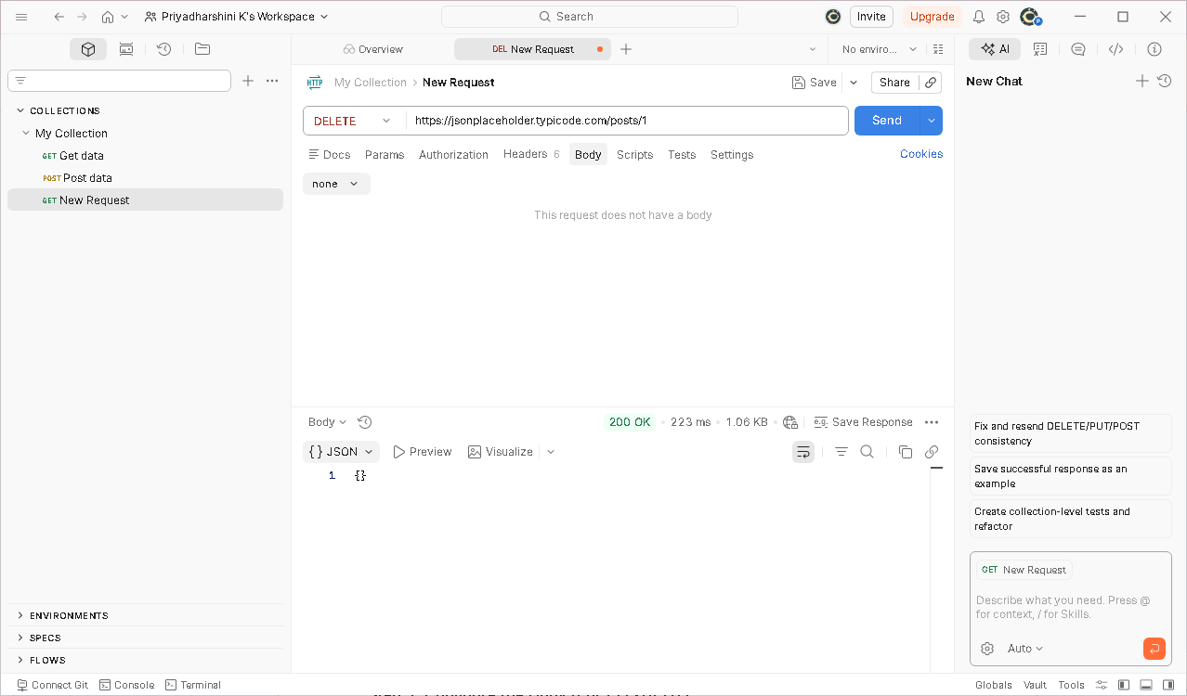

3. Step-by-Step Execution Guide
To document the process for a team, use these standardized steps for each method:

Step 1: Set the Request Type & URL
- Open a new tab in Postman.
- Select the method (GET, POST, etc.) from the dropdown menu.
- Enter the Endpoint URL (e.g., https://api.example.com/v1/users).

Step 2: Configure Headers (If Required)
- Click the Headers tab.
- Common headers include Content-Type: application/json (tells the server you are sending JSON) and Authorization: Bearer [Token] (for security).

Step 3: Configure the Body (For POST/PUT)
- Navigate to the Body tab.
- Select the raw radio button and change the text type to JSON.
- Enter the data payload in the editor.

Step 4: Analyze the Response
- Click Send.
- Status Code: Look for 200 OK (Success), 201 Created (Success for POST), or 400/500 (Errors).
- Body: Examine the returned data to ensure the server processed the request as expected.

ACTIVITY-2

GITHUB COMMANDS

Introduction to GitHub & Version Control
Git is a Distributed Version Control System (DVCS) that tracks changes in source code during software development. GitHub is a cloud-based hosting service that lets you manage Git repositories and collaborate with others.

Key Concepts for Documentation
- Repository (Repo): A project folder containing all files and the history of changes.
- Remote: The version of the project hosted on GitHub servers.
- Local: The version of the project stored on your personal computer.
- Commit: A "snapshot" or permanent save point in the project history.

2. Detailed Git Commands Reference

Category A: Setup & Initialization
Used to start a project or connect your computer to GitHub.
Command | Description | Step-by-Step
git init | Initializes a new local Git repository. | Run this inside an empty folder to start tracking it.
git clone <url> | Downloads an existing project from GitHub. | Copy the URL from the GitHub "Code" button and run this.
git config --global user.name "Your Name" | Sets your identity. | Required for the first time you use Git on a computer.

Category B: The Staging & Saving Workflow
These are used daily to track your progress.
- git status
  - Purpose: Shows which files are modified, untracked, or staged.
  - Tip: Always run this before git add to see what you are about to save.
- git add <file>
  - Purpose: Moves changes from the working directory to the Staging Area.
  - Batch Command: git add . stages all changed files in the current folder.
- git commit -m "Description"
  - Purpose: Saves the staged snapshot to the local database.
  - Note: The message should be present-tense (e.g., "Add login feature," not "Added login feature").

Category C: Branching & Merging
Used to work on features without breaking the "Main" code.
- git branch: Lists all branches in your repository.
- git checkout -b <branch-name>: Creates a new branch and switches to it immediately.
- git checkout <branch-name>: Switches back to an existing branch (like main).
- git merge <branch-name>: Joins the history of the specified branch into your current branch.

Category D: Remote Synchronization
Used to share your code with the team on GitHub.
- git remote add origin <url>: Links your local repo to a GitHub repo (only done once).
- git push origin <branch-name>: Sends your local commits to the GitHub server.
- git pull: Fetches the latest code from GitHub and merges it into your local files. Always do this before starting work.

The Full GitHub Workflow
To maintain a clean project, follow this industry-standard workflow:

Step 1: Update Local Environment
Ensure you have the latest code from your team.
Bash
git checkout main
git pull

Step 2: Create a Feature Branch
Isolate your work so you don't break the stable code.
Bash
git checkout -b feature-user-profile

Step 3: Develop and Commit
Work on your files, then stage and save them.
Bash
git add .
git commit -m "Create user profile layout"

Step 4: Push to GitHub
Upload your branch to the cloud.
Bash
git push origin feature-user-profile

Step 5: Pull Request (PR)
- Go to the repository on GitHub.com.
- Click "Compare & pull request."
- Describe your changes and ask a teammate to review the code.

Step 6: Merge and Cleanup
Once approved, the code is merged into main on GitHub. Afterward, delete your local branch:
Bash
git checkout main
git branch -d feature-user-profile

Action | Command
Download Project | git clone <url>
Check Changes | git status
Stage Files | git add .
Save Locally | git commit -m "message"
Upload to Cloud | git push origin <branch>
Update from Cloud | git pull
New Branch | git checkout -b <name>

WATERFALL,AGILE AND DEVOPS

1. Waterfall Model

Definition
- Waterfall is a linear software development model where work is done step by step.
- Each phase must finish completely before the next phase starts.
- Requirements are collected and fixed at the beginning of the project.
- Testing happens after the development phase is completed.
- It is mainly used for projects where requirements are clear and unlikely to change.

Steps in Waterfall
- Requirement Gathering
  - Collect all project requirements from the client.
- System Design
  - Plan system architecture, database, and UI design.
- Development (Coding)
  - Developers write code based on the design.
- Testing
  - Testers test the entire system for bugs.
- Deployment
  - The completed software is released to users.
- Maintenance
  - Bugs are fixed and updates are provided after release.

2. Agile Model

Definition
- Agile is an iterative and flexible software development approach.
- The project is divided into small cycles called sprints.
- Each sprint usually lasts 2 to 4 weeks.
- Development and testing happen together in every sprint.
- Customer feedback is taken frequently to improve the product.

Steps in Agile
- Product Backlog
  - List of all features, tasks, and requirements.
- Sprint Planning
  - Team selects tasks from the backlog for the sprint.
- Sprint Development
  - Developers build the features.
- Testing
  - Testers test the features during the same sprint.
- Sprint Review
  - Completed features are shown to the customer.
- Sprint Retrospective
  - Team discusses improvements for the next sprint.

3. DevOps

Definition
- DevOps is a culture and practice that combines Development and Operations teams.
- It focuses on automation and continuous software delivery.
- Development, testing, deployment, and monitoring happen continuously.
- It improves collaboration between development and operations teams.
- The goal is faster and more reliable software releases.

Steps in DevOps Lifecycle
- Plan
Plan tasks and requirements.
- Develop
Developers write and update code.
- Build
Combine and compile code.
- Test
Automated testing checks code quality.
- Release
Prepare the application for deployment.
- Deploy
Deploy the application to production.
- Operate
Run and manage the system.
- Monitor
Monitor performance and detect issues.

Difference
Feature | Waterfall | Agile | DevOps
Development Style | Sequential (step-by-step) | Iterative (small cycles) | Continuous process
Requirement Changes | Very difficult | Easy to change | Very flexible
Delivery | Delivered once at the end | Delivered in small increments | Continuous delivery
Testing | After development phase | During every sprint | Automated continuous testing
Customer Involvement | Only in the beginning and end | Continuous feedback | Continuous monitoring and feedback
Speed of Development | Slow | Faster | Very fast
Team Collaboration | Limited collaboration | Strong collaboration | Very strong collaboration
Automation | Very little | Some automation | High level of automation
Risk Handling | High risk because testing happens late | Lower risk due to frequent testing | Very low risk due to automation and monitoring

